CMP9132M Programming an AI with Stochastic Actions to solve a MDP problem in a partially and fully observable environment



line 1: 2nd Stephen Rerri-Bekibele  
line 2: *School of Computer Science. University of Lincoln   
(of Affiliation)*line 3: Lincoln, United Kingdom  
line 4: 16663359@students.lincoln.ac.uk

*Abstract*— Programming an AI to navigate an environment is a very common occurrence in the gaming world. There are many different path finding algorithms [2] and ways this has been done. From A*[3] to Dijkstra’s algorithm [4]. The aim of this research paper is to take on such a task and use an MDP [1] approach to program an AI to survive as-long-as possible in arenas of varying sizes, whilst also collecting bonuses in both a deterministic and non-deterministic scenario. This is repeated for a partially observable world as well as a fully observable world while the AI is also dealing with Stochastic actions [6]. The outcome of this research paper proves that an AI is more capable of effective planning and surviving longer when using MDP solutions in a deterministic scenario than it is in a non-deterministic scenario.

Keywords—MDP, survive, deterministic, planning, solutions, observable, Stochastic actions (key words)

# Introduction

In order to talk about implementing a path finding algorithm we must first look at some useful terminology and words which are integrated into the decision-making process. More commonly referred to as: Complex decision making [5]. Complex decision making is all about linking decisions together. This is extremely crucial when one decision leads to another; and each decision depends on the ones before and affect the ones after [6]. Making informed decisions requires knowledge about the world around us. This is true for any time of world whether real or simulated. The level of this knowledge is discretely referred to as fully observable or partially-observable in the context of world information.

A “fully observable” world is one where we always have access to all the information about the world “all the time”. A “partially observable” world is one where we do not have access to all the information about the world all the time (Simon, 2022). We may start off with some information, the rest of which may be acquired over time via exploration, or another means. However, at no point can we have all the information about the world all the time, unlike a fully observable world. This is significant because it means a partially observable world is always limited by its view of the world. Within the Complex Decision-making process, Deterministic and Non-Deterministic are terms used to refer to the probability of the consequences of one’s actions. In a Deterministic world, there is only one consequence no matter what action is taken; therefore, the probability of a desired consequence for of any given action is 100%. In a non-Deterministic world, the probability of a desired consequence for any given action can be between 0-100%. This reasoning is referred to as Stochastic probability [7].

# Concept

To solve this task, I chose to use a Markov Decision Process. A Markov decision process (MDP) is A Discrete-time stochastic control process. It is used to provide a mathematic framework for modelling decision making in situations where outcomes are partly random and partly under the control of a decision maker [8]. This means the control is stochastic which is the case for our AI’s actions as previously described. This was why I thought the MDP would be an effective solution to solving the maze task.

“The MDP relies on the notion of state (S), describing the current situation of the agent, action (A) affecting the dynamics of the process and reward (R), observed for each transition between states” [9]. With the knowledge of the stochastic decision process and the AI’s state at every time step, the MDP’s goal is the survival of the agent for as long as possible while collecting rewards. To solve this task, phrasing the task as an MDP problem thus means searching for a policy, in a set, which optimizes a performance criterion for the considered MDP. This policy is then used to direct the AI by giving it the best action for each state of the grid maze it is in [6].

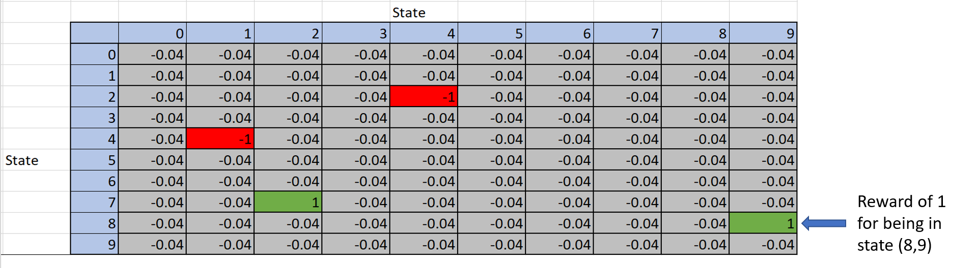

The example above is a replica of the reward matrix used in this research and illustrates that there are positive and negative rewards i.e., +1 and -1, for being in certain states of the grid such as state (8, 9) and (7, 2). In non-terminal states, the reward is set as -0.04. By assuming that the utility of a run is the sum of the reward states, the -0.04 is an incentive for the AI to take fewer steps to get to the terminal state [11].

For the base grid of size 10 by 10 used, the MDP requires as input, two matrices of data, one is a Probability matrix A.K.A transition model P (s’| s, a), of shape (A, S, S) where A are actions and S are states. This specifies an array of possible actions (A) for each state. Each S x S, then specifies the transition probabilities of reaching the second state by applying that action in the first state [6]. This meant the probability matrix would have been a (4,100,100) matrix because there were 4 possible actions the AI could take at any state.

The other, a reward matrix of shape (S, A) A.K.A reward function R(s), which specifies a set of S vectors equivalent to the S set of states, one for each state and each is a vector with one element for each of the actions. Each element, also called the expected utility, is thus the reward for executing the relevant action in the state. (This models the cost of the action is there is one) [6]. For a grid of size 10 by 10 the reward matrix was a (4,100) matrix, each column belonging to an action and each row, a state of the grid and within that state was the reward for being in said state.

The Probability and reward matrices can be generated recursively using the bellman equation [10] to compute the expected utilities for each state of the maze grid.

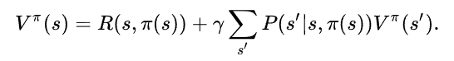

A policy much like:

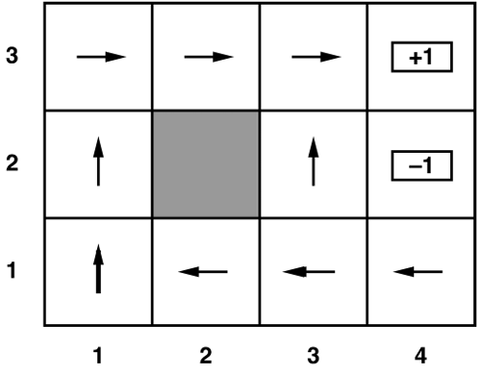

is then generated from the two tables, and this then gets the best possible action in each state and returns that value as a command to the AI when it is in each of those states.

To generate the expected utility of each state I required a motion model:

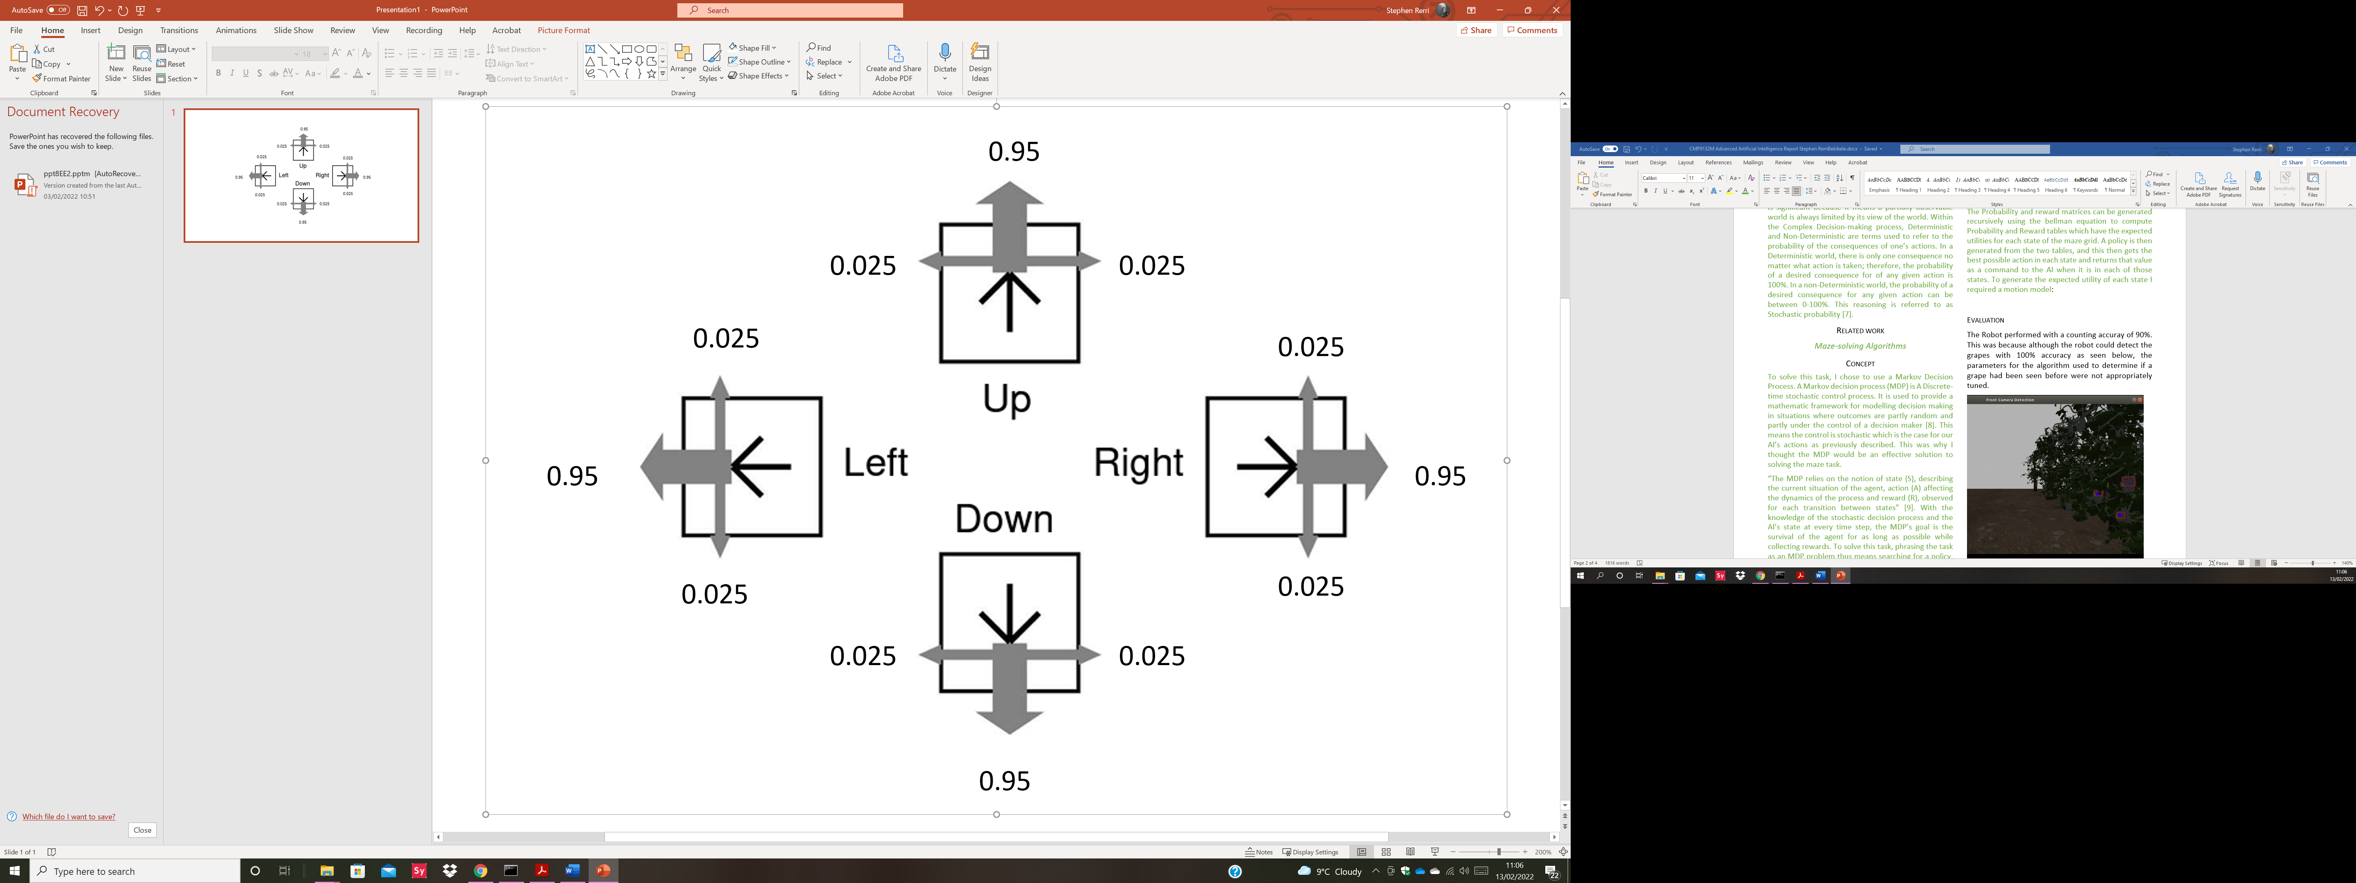

95% of the time the AI moved as intended and 0.5% of the time it moved perpendicular to the direction indented. Half the time to the left and half the time to the right.

To describe each action a transition model can be used and since the actions are stochastic, each can be described as:

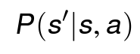

Where a is the action that takes the AI from s to s’. These transitions are assumed to be (first order) Markovian and therefore only take into consideration, the current and next states.

A “wall bouncing algorithm” had to be developed for whenever the AI hit a wall.

# Evaluation

The AI always performed better when the partially observable parameter was set to FALSE. This is because the MDP could provide a better policy to follow before too many obstacles were present as new meanies were added after a few time steps of the simulated world. Therefore, this was not recorded and instead a focus on changing parameters when partially observable was set to TRUE was taken instead.

Three scenarios were created with varying amounts of bonuses, pits, arena sizes and speed of spawning meanies.

The first scenario had a mean score of 14.6 and survival time of 9.6(s) in a 10 by 10 grid and the second scenario which has double the parameters of the first scenario had a mean score of 26.5 and survival time of 21.4(s) in a 10 by 10 grid. Lastly, the 3rd scenario which yet again doubled the parameters had a mean score of 15.8 and survival time of 14.3(s). This demonstrated that the score and survival time was highest when there were plenty of rewards and grid space up to a certain point, after which grid space became too cluttered for evasion to be more successful and therefore the AI was getting caught more quickly, resulting in a lower score and survival time. Tables of results can be found below in the Appendix

##### Acknowledgment

I would like to acknowledge Simon Parsons for his brilliant teaching and for bringing to light, techniques that were applied to this project

##### References

1. Toussaint, M., Harmeling, S. and Storkey, A., 2006. Probabilistic inference for solving (PO) MDPs. Technical Report EDI-INF-RR-0934, School of Informatics, University of Edinburgh.
2. Korf, R.E., 1988. Optimal path-finding algorithms. In Search in artificial intelligence (pp. 223-267). Springer, New York, NY.
3. Lester, P., 2005. A* pathfinding for beginners. online]. GameDev WebSite. http://www. gamedev. net/reference/articles/article2003. asp (Acesso em 08/02/2009).
4. Goyal, A., Mogha, P., Luthra, R. and Sangwan, N., 2014. Path finding: A* or dijkstra's?. International Journal in IT & Engineering, 2(1), pp.1-15.
5. Qudrat-Ullah, H., Spector, J.M. and Davidsen, P. eds., 2007. Complex decision making: Theory and practice. Springer.
6. Simon Parsons, 2022. Lecture 7: Complex decision making. https://uol.cloud.panopto.eu/Panopto/Pages/Viewer.aspx?id=b69f615e-0f8f-45d0-9dcf-adef00962046
7. Florescu, I., 2014. Probability and stochastic processes. John Wiley & Sons.
8. Wikipedia, 2022. Markov decision process. https://en.wikipedia.org/wiki/Markov_decision_process
9. Garcia, F. and Rachelson, E., 2013. Markov decision processes. Markov Decision Processes in Artificial Intelligence, pp.1-38.
10. Peng, S., 1992. A generalized dynamic programming principle and Hamilton-Jacobi-Bellman equation. Stochastics: An International Journal of Probability and Stochastic Processes, 38(2), pp.119-134.
11. Simon Parsons, 2022. Lecture 9: Markov Decision Process. https://uol.cloud.panopto.eu/Panopto/Pages/Viewer.aspx?id=6f0e8ec4-045d-401d-b4c1-adf600963e25

***Appendix***

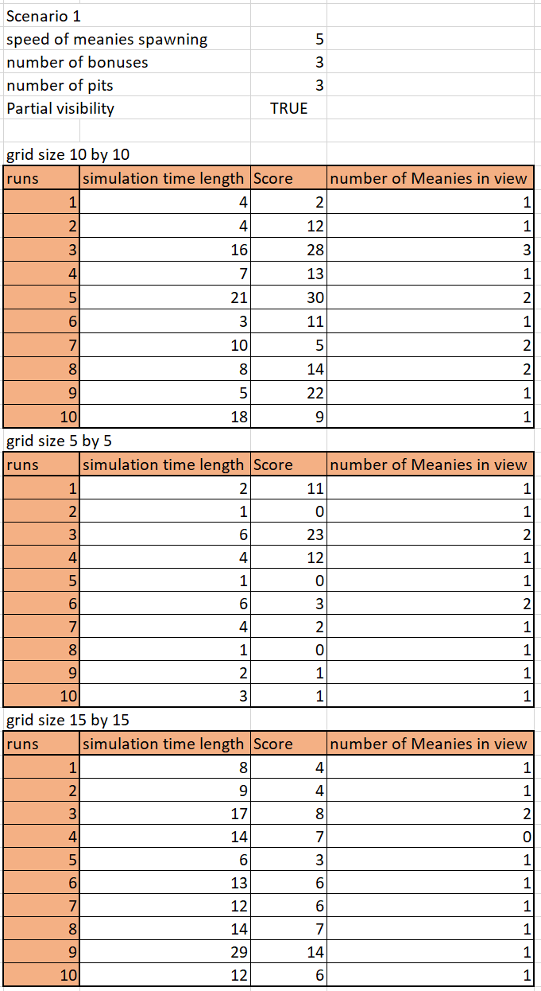

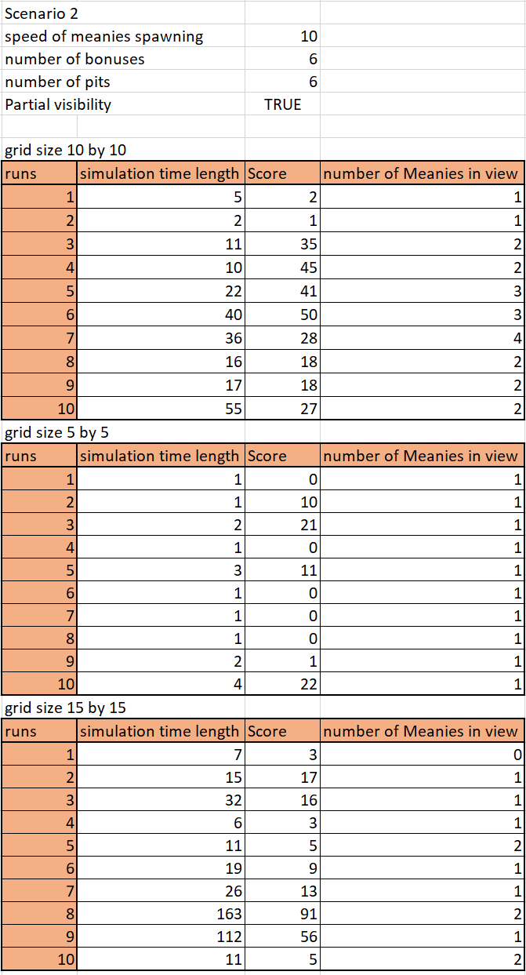

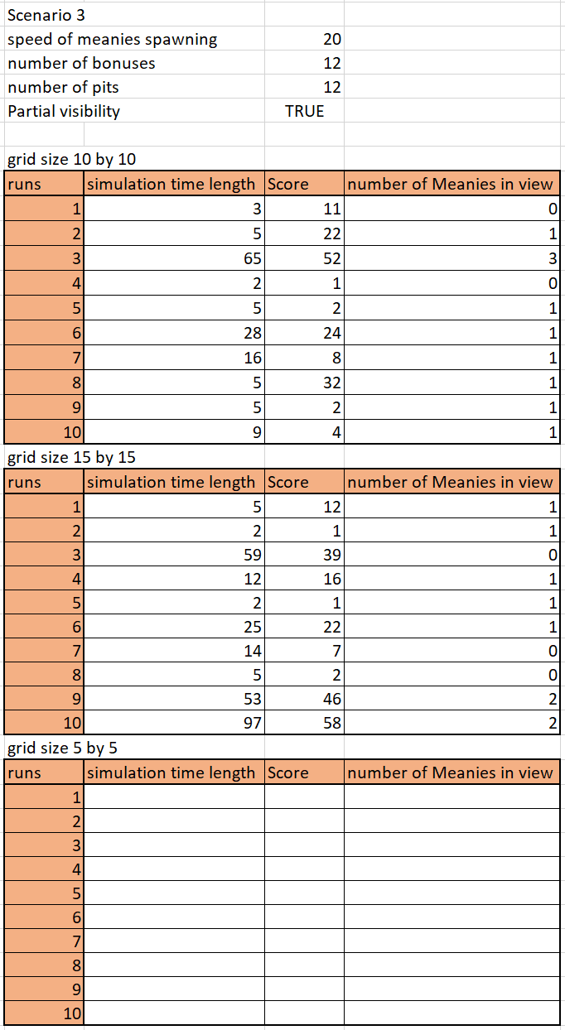

*The last scenario does not test a 5 by 5 grid because it is not possible to simulate this as the grid dimensions are too small to spawn in all the assets*